***Hive Assignment - 1***

Adarsh Hegde

1NT18IS011

ISE –A

* Create database called customer
* Create table bank(tid, bname, cname, amount)
* Insert values using insert statement
* Import the values using csv
* Query operation, group by, aggregate, order by and having clause ,views
* Create one more table
* Experiment with join operation ,Alter operations

­­­

Create table bank(tid, bname, cname, amount).

Insert values using insert statement.

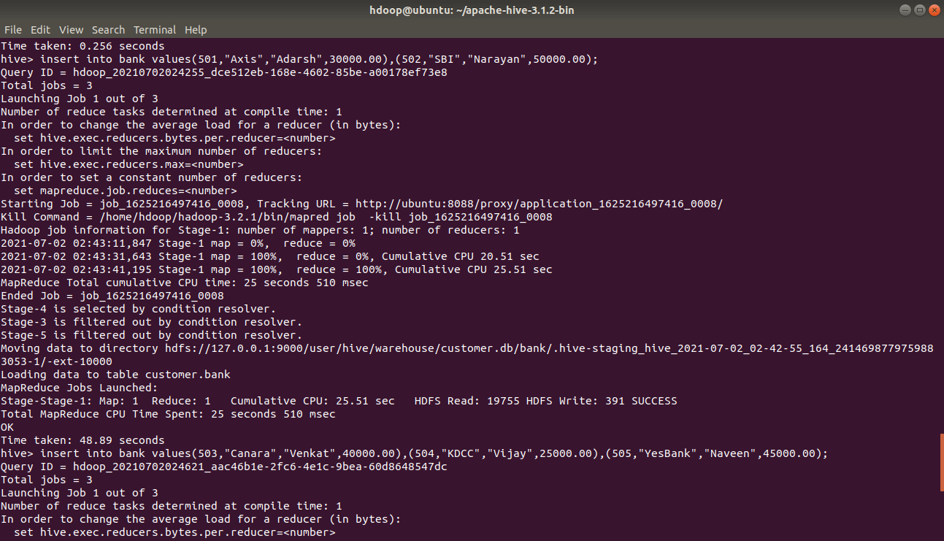

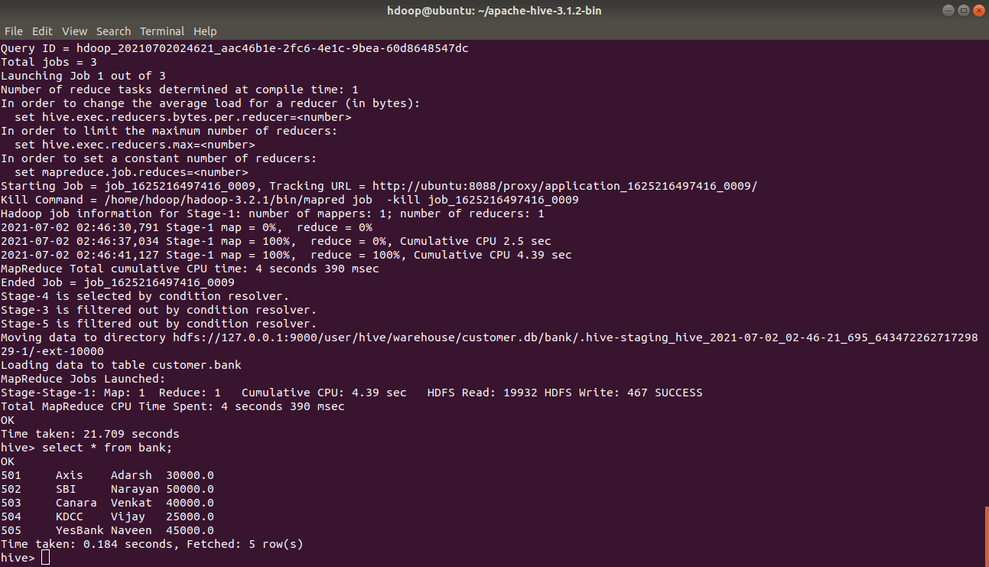

Import the values using csv

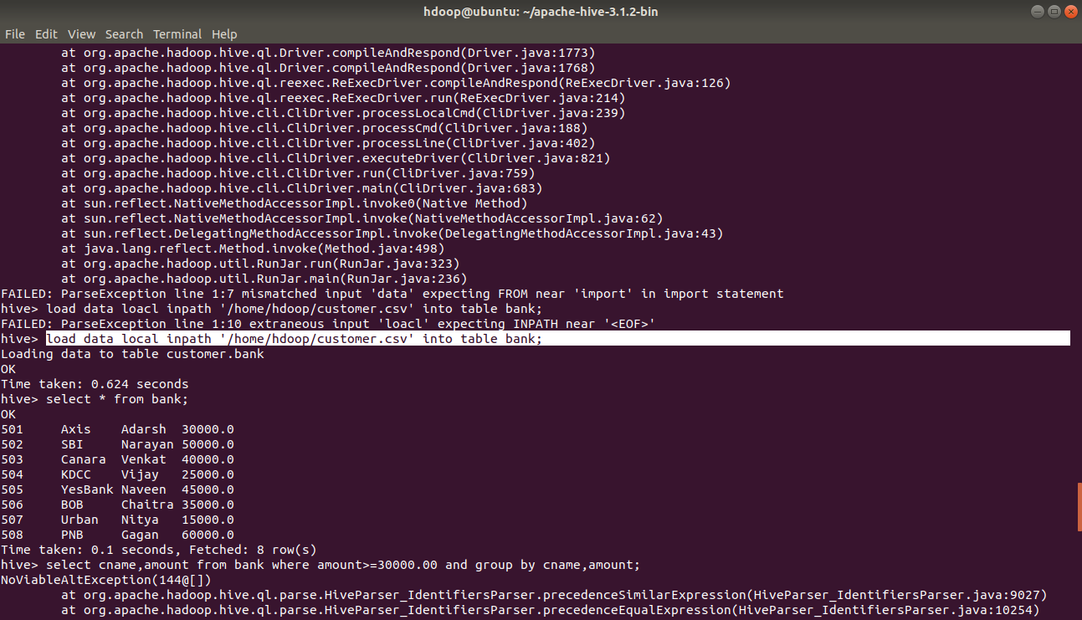

Query using group by clause

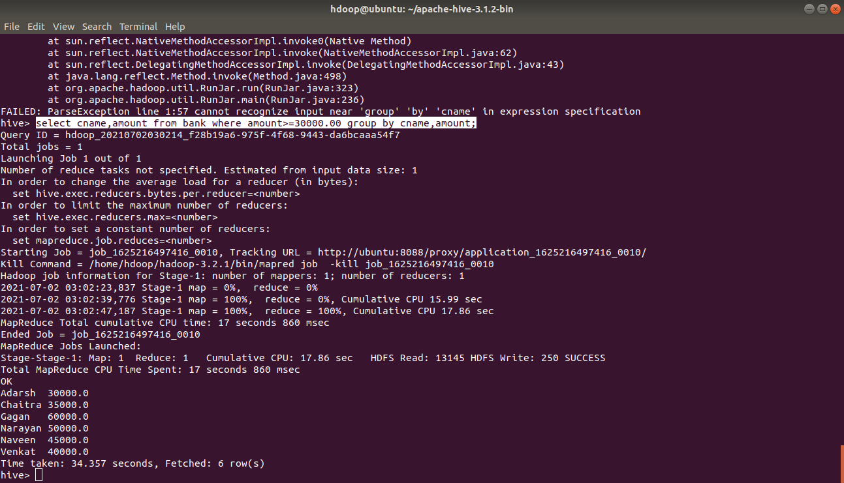

Query using order by clause

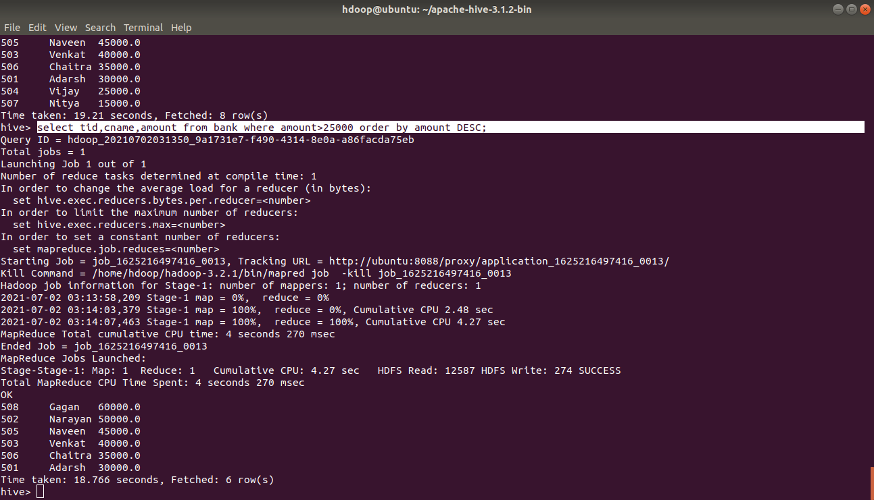

Query using having clause

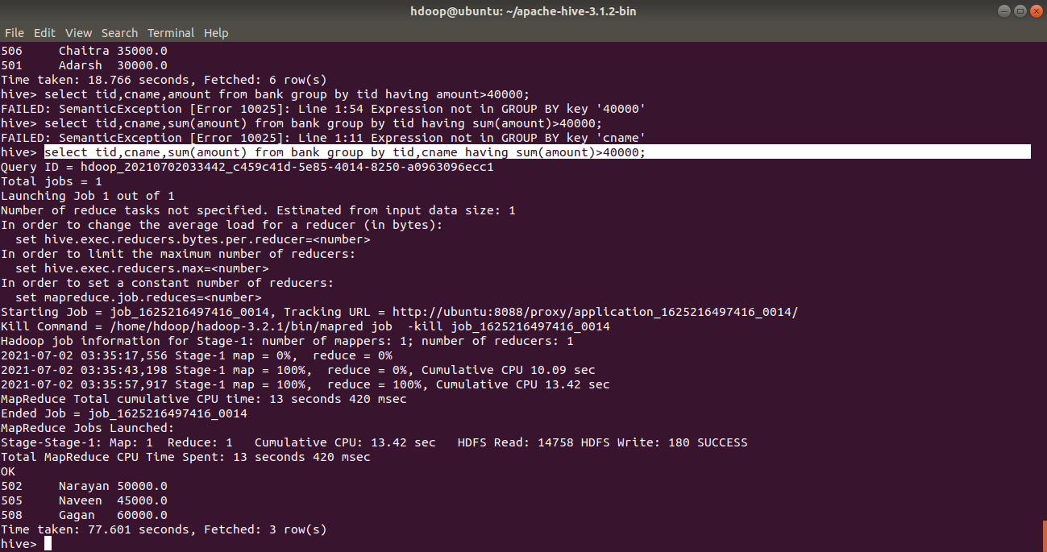

Query on aggregate functions

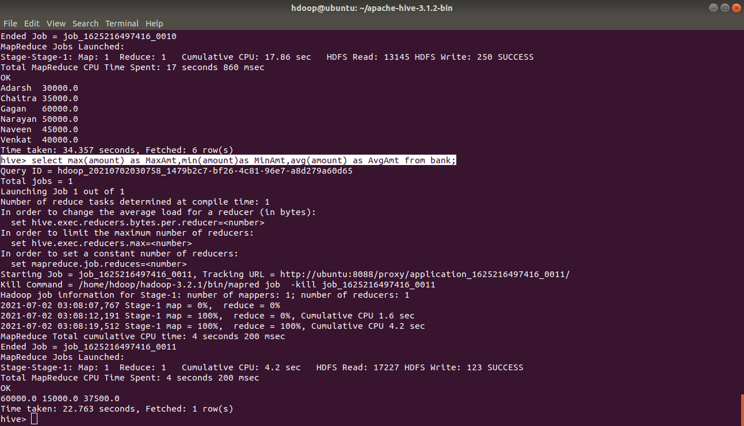

Construction of view

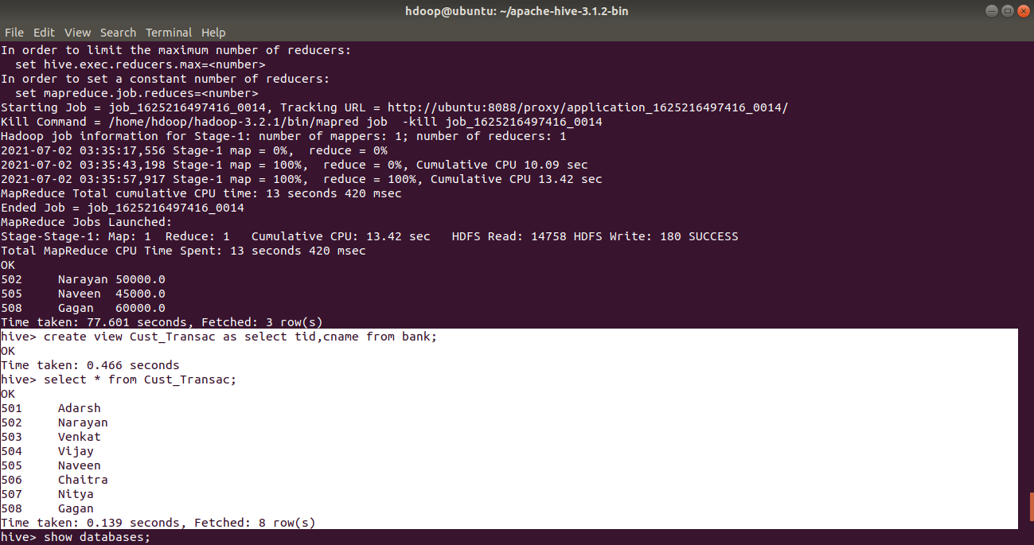

Creating one more table called customer(cust_id int,tid int,loc string)

And importing values from csv file

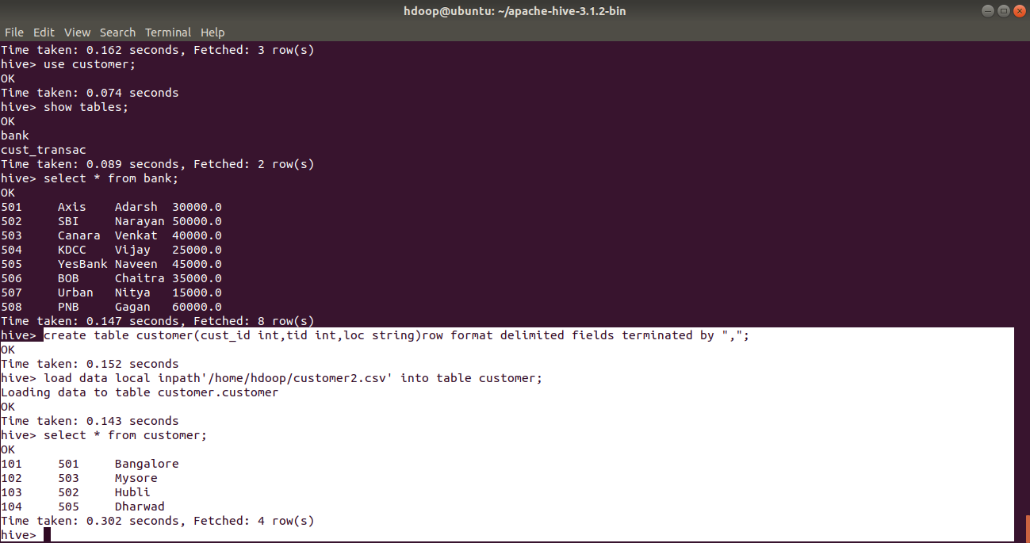

Experimenting on join operation

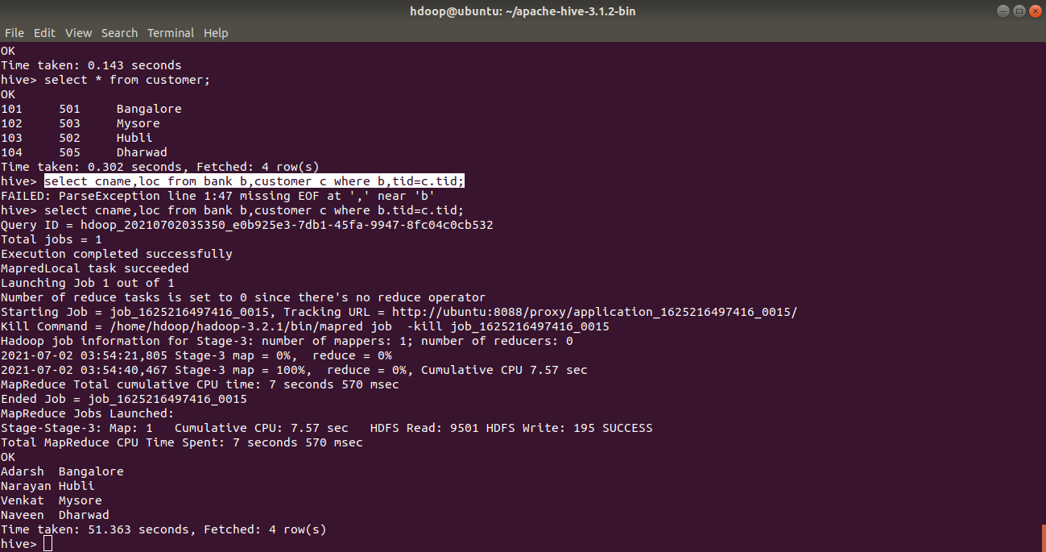

Experimenting on alter operation

